Press Release
Glashütte, October 2017

Moritz Grossmann presents the BENU Enamel

A watch with the rare combination of a steel case and an enamel dial

Gotham Hall opens its doors for WatchTime New York 2017 on 13 and 14 October. The international community of watch enthusiasts and collectors celebrates the biggest exhibition of luxury timepieces in the USA. Moritz Grossmann is present for the third time and will unveil the BENU Enamel exclusively in New York.

The BENU Enamel is a rare luxurious dress watch just launched for fans of cool steel cases. The BENU series marks the beginning of a new era for the Moritz Grossmann brand. It embodies the DNA of the Glashütte manufacture: pure watchmaking artistry since 1854.

The enamel dial is one of the hallmarks of sublime artisanship that is appreciated by connoisseurs of pure colour and praised for its unique sheen. The sublime face of the BENU Enamel features a crisp minute scale and elegant Arabic numerals. It expresses its personality with two colour variations on a white enamel dial: the scales and numerals are black or blue, combined with hands annealed to a brown-violet hue.

The calibre 100.1 movement

The 100.1 manufacture calibre features the High-Artistic finish and can be admired through the display back of the steel case. Endowed with the Grossmann balance, the Grossmann winder with pusher, the modified Glashütte stopwork, and the Grossmann micrometer screw, it represents a fusion of the arts in precision.

Versions

The BENU Enamel is being presented in two versions, each in limited 18-watch editions per year.
BENU Enamel black: White enamel dial, black numerals, black alligator strap
BENU Enamel blue: White enamel dial, blue numerals, blue alligator strap

Debut in New York

Moritz Grossmann is premiering the BENU Enamel at Watch Time New York. The international community of horology enthusiasts and collectors is convening there on 13 and 14 October 2017 at one of the most illustrious exhibitions of luxury watches, including several exceptional models for the US market.
http://www.watchtimenewyork.com/

Versions:

BENU Enamel black
Reference MG-001405
Case stainless steel
Dial Grand-feu enamel, Arabic numerals in black
Hands Manually crafted, steel annealed to a brown-violet hue
Edition Limited to 18 watches per year worldwide

BENU Enamel blue
Reference MG-001404
Case stainless steel
Dial Grand-feu enamel, Arabic numerals in blue
Hands Manually crafted, steel annealed to a brown-violet hue
Edition Limited to 18 watches per year worldwide

Technical data:

Movement Manufacture calibre 100.1, manually wound, adjusted in five positions
No. of parts 198
No. of jewels 20 jewels, 3 of which in screwed gold chatons
Escapement Lever escapement
Oscillator Shock-absorbed Grossmann balance with 4 inertia and 2 poising screws, Nivarox 1 balance spring with No. 80 Breguet terminal curve, Gerstenberger geometry
Balance Diameter 14.2 mm, frequency 18,000 semi-oscillations per hour
Power reserve 42 hours when fully wound
Functions Hours and minutes, subsidiary seconds with stop seconds, Grossmann winder with pusher
Special features Grossmann balance; lateral pusher for disabling the handsetting mode and starting the movement; space saving and modified Glashütte stopwork with backlash; adjustment with Grossmann micrometer screw on a cantilevered balance cock; Pillar movement with 2/3 plate and frame pillars in untreated German silver; 2/3 plate, balance cock, and escape-wheel cock engraved by hand; broad horizontal Glashütte ribbing; 3-band snailing on the ratchet wheel; raised gold chatons with pan-head screws; separately removable clutch winder; stop seconds for handsetting
Operating elements Crown to wind the watch and set the time, pusher to start the movement
Case dimensions Diameter: 41.0 mm, height: 11.35 mm
Movement dimensions Diameter: 36.4 mm, height: 5.0 mm
Case Three-part, stainless steel
Dial Grand-feu enamel, Arabic numerals
Hands Hand-crafted, steel annealed to a brown-violet hue
Crystal/display back Sapphire crystal, antireflection-coated on one side
Strap Hand-stitched alligator strap with prong buckle

Moritz Grossmann Uhren:
Moritz Grossmann, born in Dresden in 1826, was deemed a visionary among Germany’s great horologists. In 1854, his friend Ferdinand Adolph Lange persuaded the young, highly talented watchmaker to establish his own mechanical workshop in Glashütte. Apart from building a respected watchmaking business, Grossmann was committed to political and social causes. He established the German School of Watchmaking in 1878. Moritz Grossmann passed away unexpectedly in 1885, after which his manufacture was liquidated.
The spirit of Moritz Grossmann’s horological traditions sprang back to life in 2008 when trained watchmaker Christine Hutter discovered the venerable Glashütte brand and had it re-registered. She developed concepts and was inspired by the vision of reviving Grossmann’s legacy more than 120 years later with a particularly exquisite wristwatch. And she convinced private watch enthusiasts to support her in making this dream come true. On 11 November 2008, she incorporated Grossmann Uhren GmbH in Glashütte.
At Grossmann, gifted watchmakers are preserving traditions without copying historic timepieces. With innovation, superb craftsmanship, a combination of traditional and contemporary manufacturing methods as well as precious materials, they are celebrateing "Pure watchmaking artistry since 1854" in their watches.

www.grossmann-uhren.com

For further information and high-resolution images, please contact:

GROSSMANN UHREN GmbH
Rainer Kern – Communication Manager
Uferstr. 1
01768 Glashütte
Tel: 0049-35053-320020
Fax: 0049-35053-320099
rainer.kern@grossmann-uhren.com

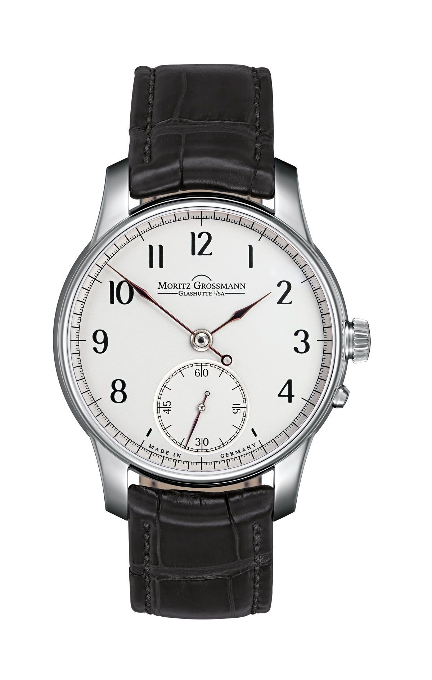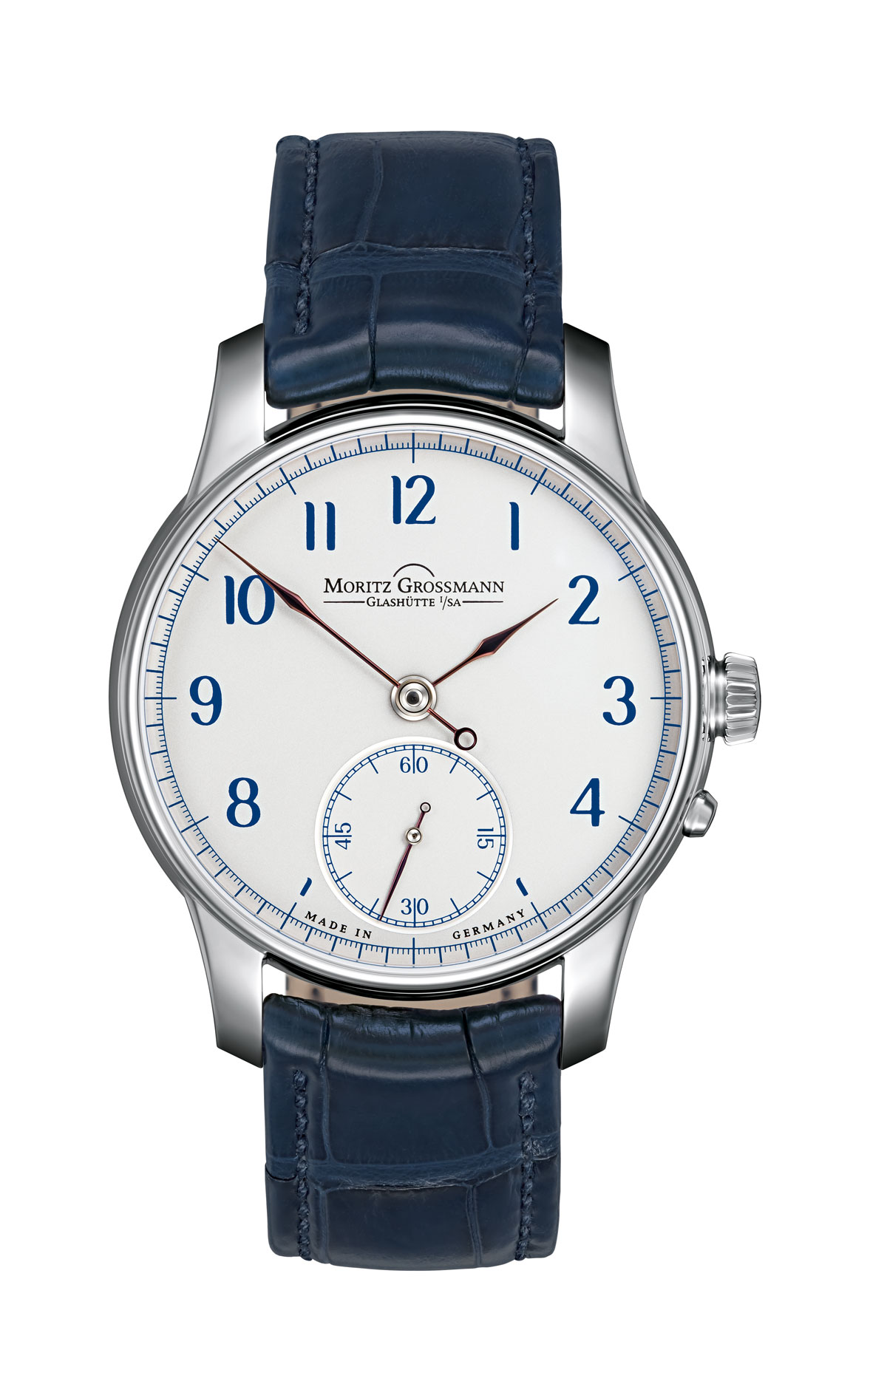
BENU Enamel black BENU Enamel blue

