Press Release
Glashütte, February 2017

Moritz Grossmann presents
the ATUM Enamel

Its hallmark: Roman numerals on a white enameled dial

In all of its versions, the ATUM line embodies pure watchmaking artistry. Each model presents a special and inimitable accent. To welcome the dawn of 2017, Grossmann is presenting the ATUM Enamel with an extravagant dial design.

The two-part dial has a white enamel face. The scales and numerals are printed in black. The Roman numeral XII is printed in royal blue to match the strap. Enameled dials were common hallmarks of precious pocket watches and remain very rare features of wristwatches. Connoisseurs appreciate the unique gloss of enamel that cannot be imitated by any lacquering method. The hands are manually crafted and annealed to a rare brown-violet hue.

The ATUM Enamel is endowed with the manufacture calibre 100.1 with the High-Artistic Finish. The Grossmann winder with pusher, the Grossmann balance, the modified Glashütte stopwork, the beat adjustment system with an index tail, and the Grossmann poising screw are the key elements of the pillar movement with the prominent 2/3 plate.

Versions

The ATUM Enamel is presented rose-gold and white-gold versions. Both versions come with a white-enameled dial printed in black except for the XII which is printed in blue, and a blue alligator strap. The ATUM Enamel is being introduced in a limited edition of 25 watches per case version.

Technical data

Movement Manufacture calibre 100.1, manually wound, adjusted in five positions
No. of parts 198
No. of jewels 20, of which 3 in screwed gold chatons
Escapement Lever escapement
Oscillator Shock-resistant Grossmann balance with 4 inertia and 2 poising screws, Nivarox 1 balance spring with No. 80 Breguet terminal curve, Gerstenberger geometry
Balance Diameter 14.2 mm, frequency 18,000 semi-oscillations per hour
Power reserve 42 hours when fully wound
Functions Hours and minutes, subsidiary seconds with stop seconds, Grossmann manual winder with pusher
Special features Grossmann balance;
Lateral pusher for disabling the handsetting mode and starting the movement;
Compact modified Glashütte stopwork with backlash;
Adjustment with Grossmann micrometer screw on a cantilevered balance cock;
Pillar movement with 2/3 plate and frame pillars in untreated German silver;
Hand-engraved 2/3 plate, balance and escape-wheel cocks;
Broad horizontal Glashütte ribbing;
3-band snailing on the ratchet wheel;
Raised gold chatons with pan-head screws;
Separately removable clutch winder;
stop seconds for handsetting
Operating elements Crown in 750/000 gold to wind the watch and set the time, pusher in 750/000 gold to start the movement
Case dimensions Diameter: 41.0 mm, height: 11.35 mm
Movement dimensions Diameter: 36.4 mm, height: 5.0 mm
Case Three-part, precious metal
Dial Grand-feu enamel, Roman numerals printed black from I to XI, blue for XII
Hands Manually crafted, steel, annealed to a brown-violet hue
Crystal and display back Sapphire crystal, antireflective coating on one side
Strap Hand-stitched alligator strap with prong buckle in precious metal

Versions:

Reference MG02.B-02-A000804
Case 750/000 rose gold
Hands Manually crafted, steel, annealed to a brown-violet hue
Edition Limited to 25 watches worldwide

Reference MG02.B-02-A000807
Case 750/000 white gold
Hands Manually crafted, steel, annealed to a brown-violet hue
Edition Limited to 25 watches worldwide

Moritz Grossmann Uhren:
Moritz Grossmann, born in Dresden in 1826, was deemed a visionary among Germany’s great horologists. In 1854, his friend Ferdinand Adolph Lange persuaded the young, highly talented watchmaker to establish his own mechanical workshop in Glashütte. Apart from building a respected watchmaking business, Grossmann was committed to political and social causes. He established the German School of Watchmaking in 1878. Moritz Grossmann passed away unexpectedly in 1885, after which his manufacture was liquidated.
The spirit of Moritz Grossmann’s horological traditions sprang back to life in 2008 when trained watchmaker Christine Hutter discovered the venerable Glashütte brand and had it re-registered. She developed concepts and was inspired by the vision of reviving Grossmann’s legacy more than 120 years later with a particularly exquisite wristwatch. And she convinced private watch enthusiasts to support her in making this dream come true. On 11 November 2008, she incorporated Grossmann Uhren GmbH in Glashütte.
At Grossmann, gifted watchmakers are preserving traditions without copying historic timepieces. With innovation, superb craftsmanship, a combination of traditional and contemporary manufacturing methods as well as precious materials, they have created an “Origin of a new time” with their watches.

www.grossmann-uhren.com

For further information and high-resolution images, please contact:

GROSSMANN UHREN GmbH
Rainer Kern – Director of Communication
Uferstr. 1
01768 Glashütte
Tel: 0049-35053-320020
Fax: 0049-35053-320099
rainer.kern@grossmann-uhren.com

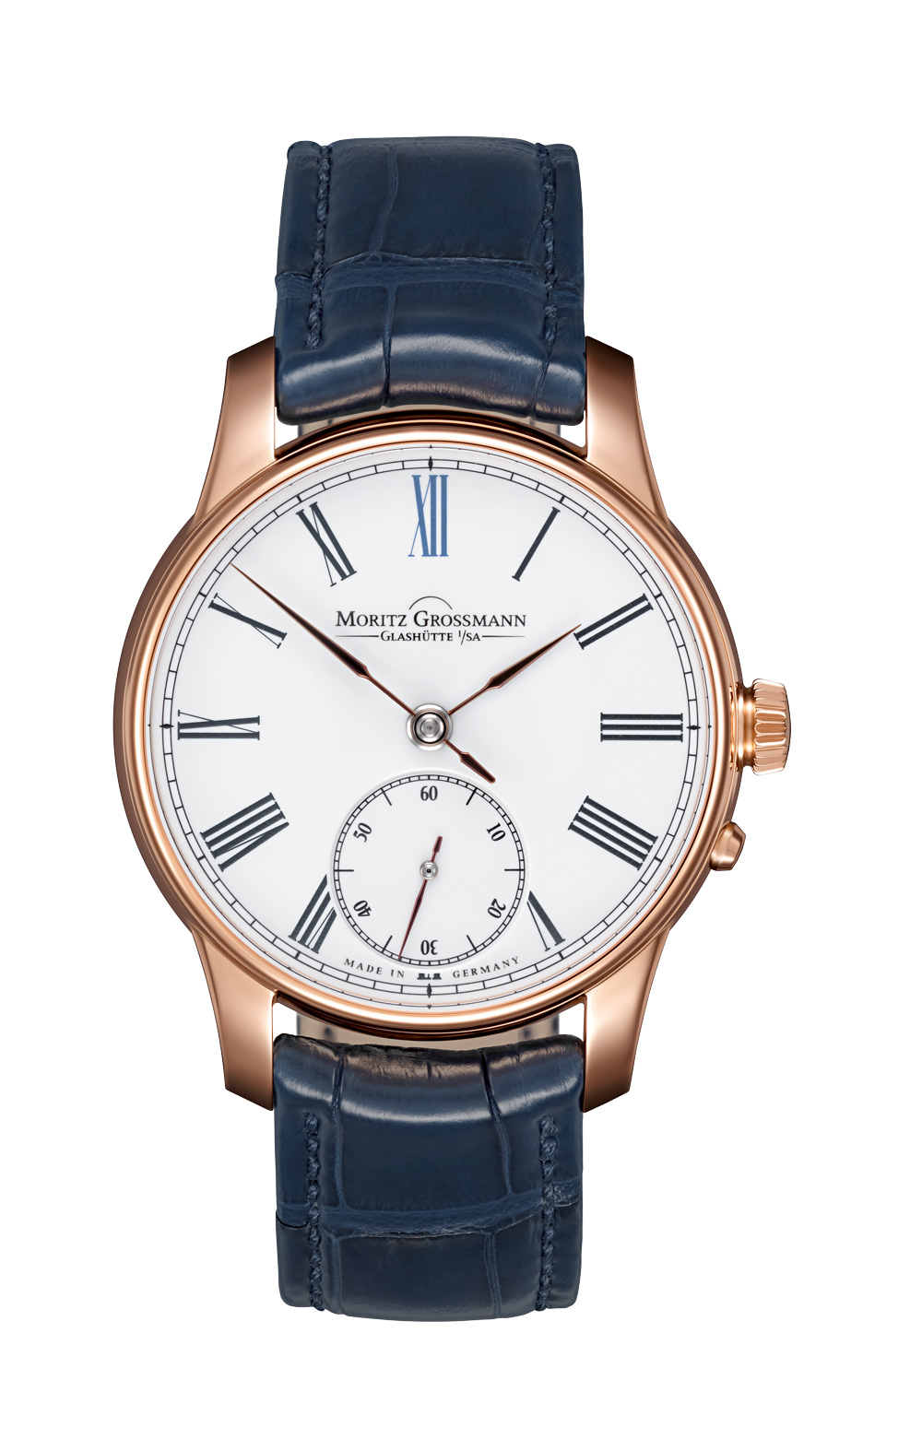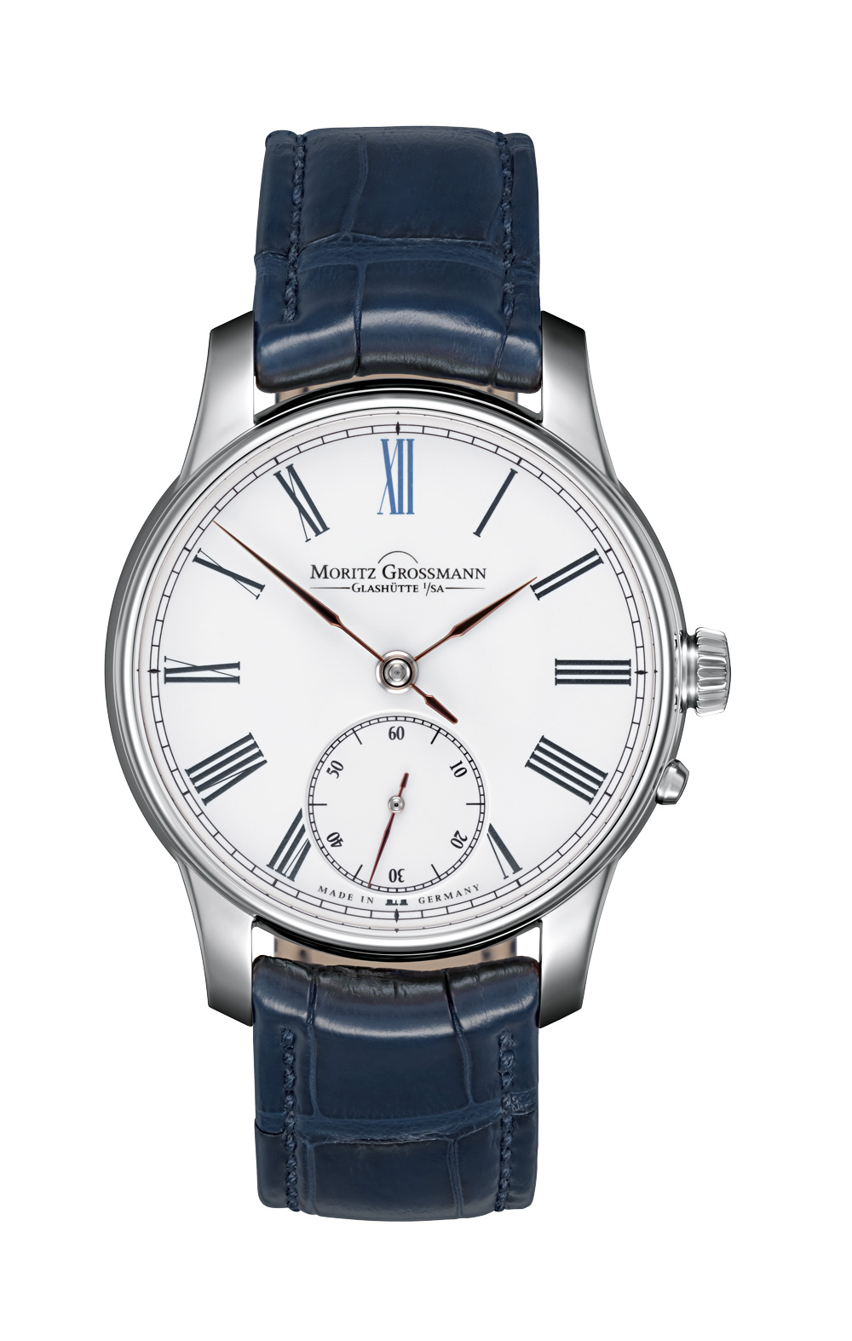
ATUM Enamel rose gold ATUM Enamel white gold

